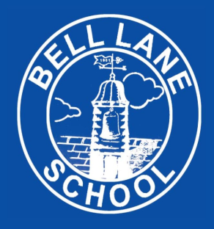
Online Safety Agreement 2020-21
KS1
My name is ____________________

This is how I keep SAFE online:
- I only use the devices I’m ALLOWED to
- I CHECK before I use new sites, games or apps
- I ASK for help if I’m stuck
- I KNOW people online aren’t always who they say
- I don’t keep SECRETS just because someone asks me to
- I don’t change CLOTHES in front of a camera
- I am RESPONSIBLE so never share private information
- I am KIND and polite to everyone
- I TELL a trusted adult if I’m upset, worried, scared or confused
- If I get a FUNNY FEELING in my tummy, I talk to an adult

My trusted adults are:
_________________________________________________ at school
_________________________________________________ at home

