Phonics

Children who read regularly or are read to regularly have the opportunity to open the doors to so many different worlds! More importantly, reading will give your child the tools to become independent life-long learners.
We can achieve this together through:
- Read Write Inc, a program to help to your child read at school
- Encouraging children to develop a love of books by reading to them daily, at home and at school
- Giving children access to a wide range of books at school and at home

At Bell Lane we use Read Write Inc Phonics (RWI) to give your child the best possible start with their literacy. We have put together a guide to how the RWI programme works together with some useful links.

Mrs Janice Doherty are our Read Write Inc lead teacher and Mrs Donika Aarpai RWI Support Assistant, so if you have questions about RWI, contact school who can refer you to her. Please take the time to read the information as it will provide invaluable information as to how you can help and support your child in reading.

What is Read Write Inc?
Read Write Inc (RWI) is a phonics complete literacy programme which helps all children learn to read fluently and at speed so they can focus on developing their skills in comprehension, vocabulary and spelling. The programme is designed for children aged 4-7. However, at DWIS we begin the programme in Nursery and will continue teaching RWI to children beyond the age of 7 if they still need support in their reading.
RWI was developed by Ruth Miskin and more information on this can be found at https://ruthmiskin.com/en/find-out-more/parents/.

Follow the below link: An overview of Read Wring Inc Phonics
https://www.youtube.com/watch?v=-6dSsXkD1wM

How will RWI be taught?
All children are assessed regularly by our RWI lead teacher so they work with children at the same level. This allows complete participation in lessons.

Nursery
When appropriate, children will be introduced to the initial sounds in short five minutes sessions.
Reception
In Reception all children will learn how to ‘read’ the sounds in words and how those sounds can be written down.

Reading
The children:
- learn 44 sounds and the corresponding letters/letter groups using simple picture prompts – see below
- learn to read words using Fred talk and sound blending
- read from a range of storybooks and non-fictions books matched to their phonic knowledge
- work well with partners
- develop comprehension skills in stories by answering 'Find It' and 'Prove It' discussion questions

Writing
The children:
- learn to write and form the letters/letter groups which represent the 44 sounds with the help of fun phrases
- learn to write words by using Fred Talk
- learn to build sentences by practising sentences out loud before they write

Talking
The children
- They work in pairs so that they:
- answer every question
- practise every activity with their partner
- take turns in talking and reading to each other
- develop ambitious vocabulary

Year One & Year Two
Children follow the same format as Reception but will work on complex sounds and read books appropriate to their reading level. Daily sessions of RWI phonics last for one hour. Once children become fluent speedy readers they will move on to literacy in Year One and Active English in Year Two.

Five key principles underpin the teaching in all Read Write Inc. sessions:
Purpose – know the purpose of every activity and share it with the children, so they know the one thing they should be thinking about
Participation – ensure every child participates throughout the lesson. Partnership work is fundamental to learning
Praise – ensure children are praised for effort and learning, not ability
Pace – teach at an effective pace and devote every moment to teaching and learning
Passion – be passionate about teaching so children can be engaged emotionally.

Children will be taught how to read as follows:
Before you start to teach your child, practise saying the sounds below.These are the sounds we use to speak in English.

Fred Talk
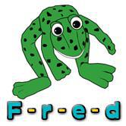
We use pure sounds (‘m’ not’ muh’,’s’ not ‘suh’, etc.) so that your child will be able to blend the sounds into words more easily.
At school we use a puppet called Fred who is an expert on sounding out words! we call it, ‘Fred Talk’. E.g. m-o-p, c-a-t, m-a-n, sh-o-p, b-l-a-ck.

The following video is an example of blending sounds with Fred. https://www.youtube.com/watch?v=dEzfpod5w_Q

The children are taught the sounds in 3 sets.

Set 1:
Set 1 Sounds are taught in the following order together with rhymes to help children form the letters correctly and instantly recognise sounds ready for blending.
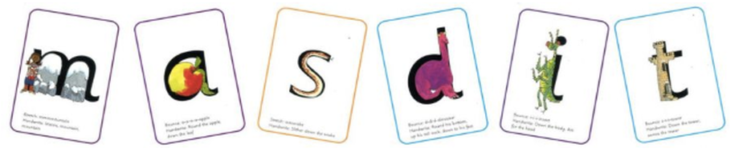
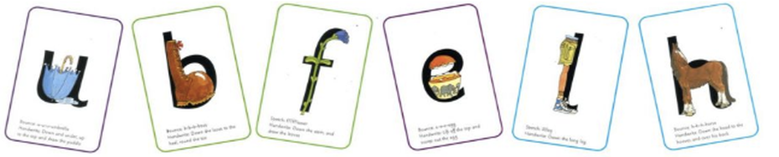
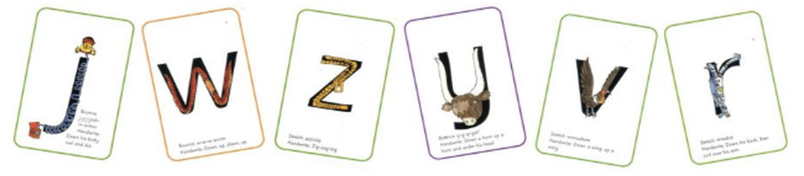
To hear the sounds click on the link below

Set 2:
The children are then taught Set 2 Sounds - the long vowels. When they are very confident with all of set 1 and 2 they are taught Set 3 Sounds. ay, ee, igh, ow, oo, oo, ar, or, , air, ir, ou, oy each sound also has a phrase to help the children to remember e.g. ay – may I play?
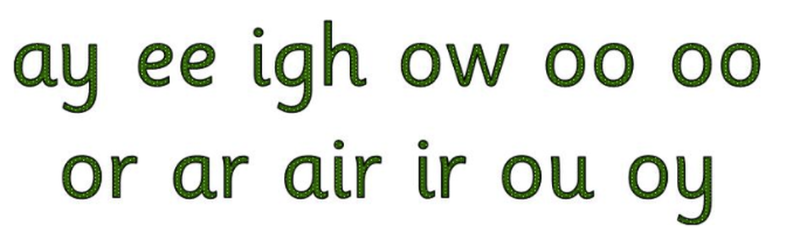 Set 3
Set 3 – 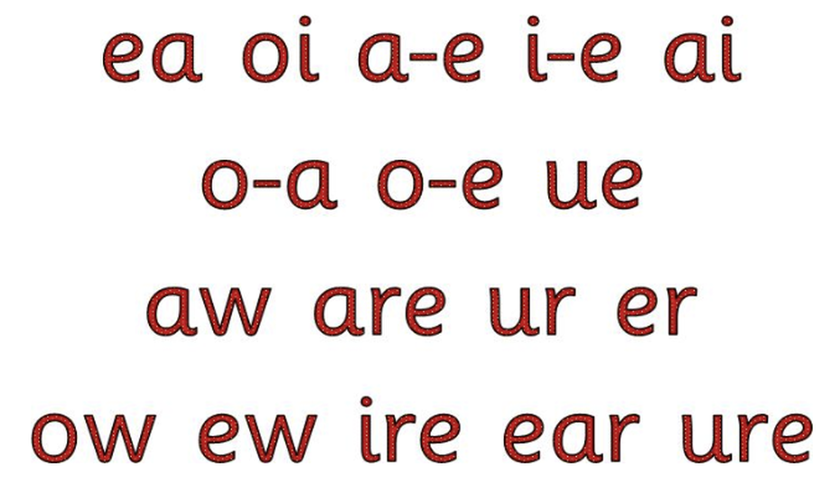
When there are sounds made by more than one letter e.g. ie, ea, air we call these special friends. There are some special friends which are too chatty and so they are not allowed to sit next to each other e.g. a_e as in mate.
These sounds are then taught within decodable Green words.
In our wonderful, challenging, eclectic English language there are words which are not decodable and need to be learnt by sight, these are Red words e.g. the, said.

Nonsense/Alien words
Nonsense words, which we also refer to as Alien words, are used to assess children’s knowledge of sounds by asking them to read the sounds they know in unknown words.
As children’s reading develops, they will need to work out longer real words that include some syllables that, on their own, have no meaning e.g. fan-tas-tic, e-nor-mous
Here are some examples of nonsense/alien words for each stage of Read, Write Inc. just to give you an idea of the types of words and sounds your children will encounter.

VideoPure Sounds
https://www.youtube.com/watch?v=s6OiU2h3sUI

Handwriting Phrases to help your child to form letters
Link to Handwriting Phrases
Linked story books to the RWI books
Link to the linked story books.

A list if high frequency words
Link to the linked to the word mat.

