Handwriting Policy

At Bell Lane Primary School we are very proud of our pupil’s handwriting and take particular care in our cursive/joined-up handwriting style. We use Letter-join as the basis of our handwriting policy that covers all the requirements of the 2014 National Curriculum.

Handwriting is a basic skill that influences the quality of work throughout the curriculum. At the end of Key Stage 2 all pupils should have the ability to produce fluent, legible and, eventually, speedy joined-up handwriting, and to understand the different forms of handwriting used for different purposes.

We aim to make handwriting an automatic process that does not interfere with creative and mental thinking.

As a catalyst to speedy handwriting we encourage parents and carers to use the Letter-join resources at home and can arrange for free access to the Home Edition of Letter-join.

Bell Lane Primary School font
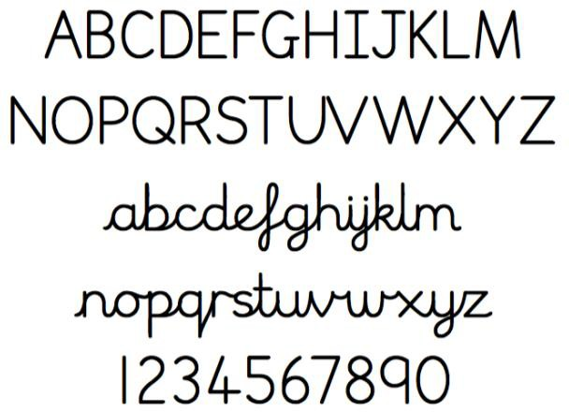

School aims
We aim for our pupils to develop a neat, legible, speedy handwriting style using continuous cursive letters that leads to producing letters and words automatically in independent writing.
By the end of Year 6 pupils will understand the importance of neat presentation and the need for different letterforms (cursive, printed or capital letters) to help communicate meaning clearly.

Method
Our teachers are encouraged to use neat, joined-up cursive writing for all handwriting tasks including board writing, marking and comments.
Consistency throughout the school
Pupils should experience coherence and continuity in the learning and teaching of handwriting across all school years and be encouraged to take pride in the presentation of their work. Our aim is to help pupils enjoy learning and developing their handwriting with a sense of achievement and pride.

Handwriting frequency
Handwriting is a cross-curriculum task and will be taken into consideration during all lessons. Formal teaching of handwriting is to be carried out regularly and systematically to ensure Key Stage targets are met.

FOUNDATION:
For our youngest pupils we aim for two to three weekly sessions that will include the following;
- Movements to enhance gross motor skills
such as air-writing, pattern making, dancing.
- Exercises to develop fine motor skills such
as making marks on paper, whiteboards, blackboards, sand trays, iPads and tablets.
- Letter learning to familiarise letter shapes, formation and vocabulary.

YEARS 1 TO 3:
Tuition will continue with two or three weekly sessions totalling 30 to 45 minutes covering:
- Gross and fine motor skills exercises.
- Cursive handwriting reinforcement, learning and practice.
- Numerals, capitals and printed letters:
where and when to use, learning and practice.

YEARS 4 TO 6:
More advanced handwriting techniques will be taught during two or three weekly sessions totalling 30 to 45 minutes teaching:
- Cursive handwriting re-enforcement.
- Form-filling/labelling using printed and capital letters.
- Dictation exercises to teach the need for quick notes and speedy handwriting writing.

Correct posture and pencil grip for handwriting
Pupils should be taught to sit correctly at a table, holding a pencil comfortably and correctly.

SITTING POSITION

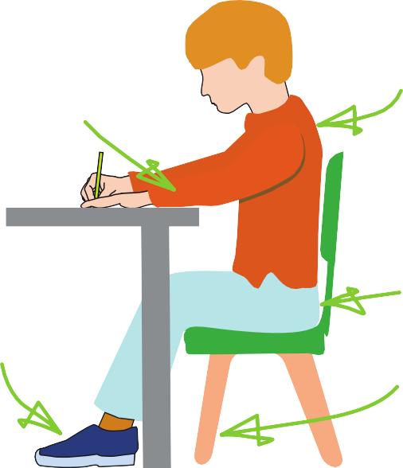
Sit with a straight back, not leaning over the
The table reaches to below elbow

Keep feet flat on the floor

Sit right back in the seat

Pull the chair close in to the table

Paper position for right- handed children

THE TRIPOD PENCIL GRIP
Both right and left handed children should be encouraged to use the tripod grip which allows the pen/pencil to be held securely whilst allowing

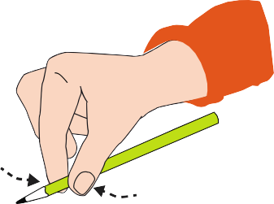
controlled movements of the pen/pencil nib.

1
- Grip the pencil with your index finger and thumb with the nib pointing away.
- With your free hand, spin the pencil from underneath.
- Use your middle finger to support the underside of the pencil.

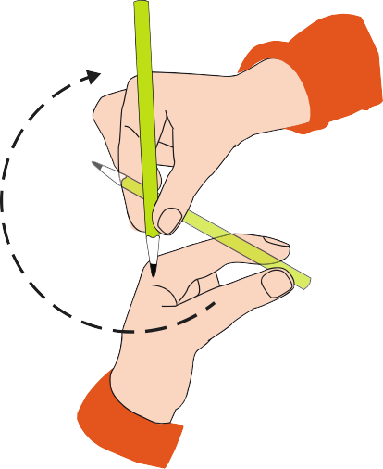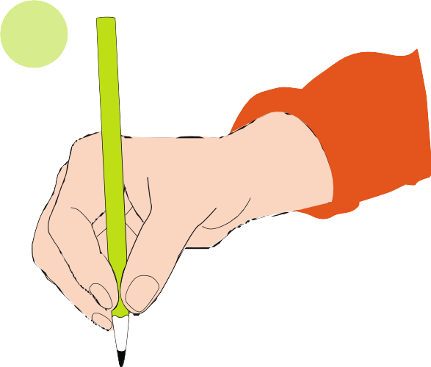
2
3
3

LEFT-HANDED CHILDREN
Left-handed children may find it difficult to follow right-handed teachers as they demonstrate letter formation (and vice versa). Teachers should demonstrate to left-handers on an individual or group basis.
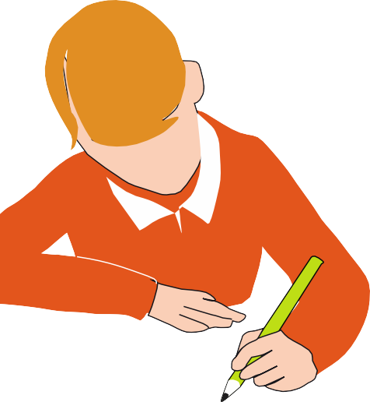
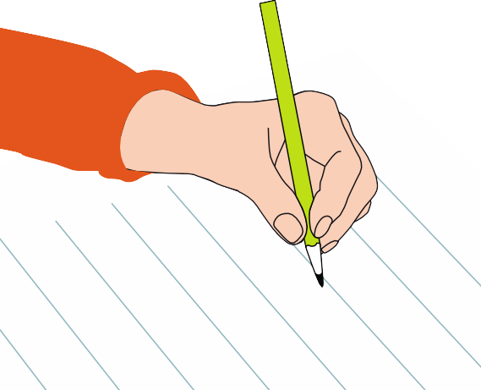

  - Left-handed pupils should sit to the left of a right-handed child so that they are not
competing for space.
  - Pupils should position the paper/book to their left side and slanted, as shown.
  - Pencils should not be held too close to the
point as this can interrupt pupils’ line of
vision.
  - Extra practice with left-to-right exercises
may be necessary before pupils write left-to-right automatically.

INCLUSION
Children whose handwriting is limited by problems with fine motor skills, including left- handed children, and children with special educational needs, will be given one-to-one tuition to help achieve their optimum handwriting level.

Paper position for left-handed children

PENS AND PENCILS
Children are encouraged to start handwriting using a soft pencil. When fine motor skills have been established a handwriting pen can be used. More competent pupils can use a
ballpoint pen.

Key Stage Teaching

FOUNDATION

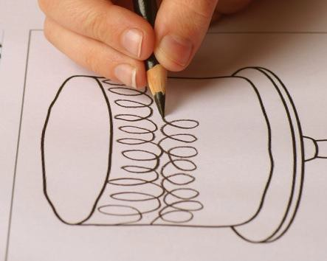
  - Sit in the correct position and hold a pencil
correctly to allow fluid movement of the nib.
  - Improve fine and gross motor skills by enjoying drawing pre-cursive patterns in a
variety of writing materials such as modelling clay, air writing, sand trays, felt
pens, crayons, pencils, IWB, iPads/tablets.
  - Understand the language need to describe pencil movements in preparation of letter

RECEPTION
  - Hold a pencil in an effective manner for writing and be encouraged to correct any
errors in grip or stature.
  - Understand that letters are written on a
base line and that all cursive letters ‘start on the line’ and ‘end with a hook’.
  - Begin to form some recognisable joined-up cursive letters, capital letters and numerals.
  - Have an understanding of writing their own name.
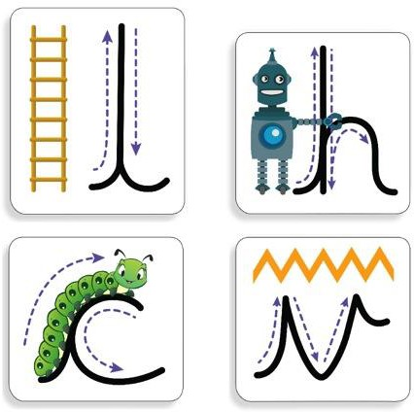
  - Understanding different shaped letter families.

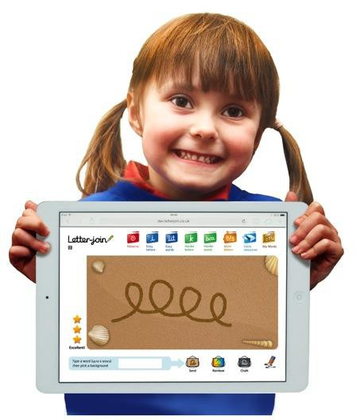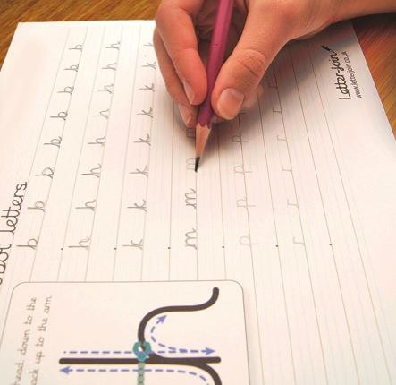

Key Stage Teaching

KEY STAGE 1

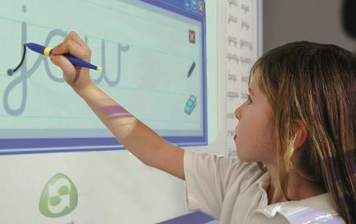
  - Write legibly using upper and lower case letters with correct joins.
  - Ensure that letters sit on the base line and
are consistent in size with ascenders and
descenders that are the correct length and formation.
  - Leave the correct space between words.
  - Form capital letters and use where appropriate.
  - Form numerals that are consistent in size
and sit on the base line.
  - Begin to form printed letters and understand when they are to be used.
  - Improve the speed of writing and begin to
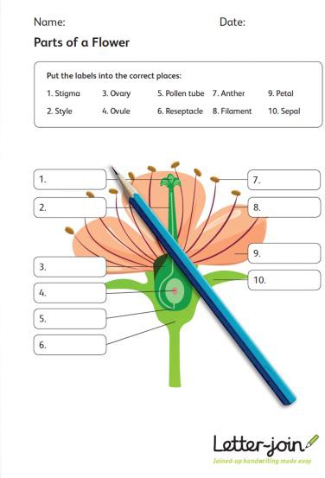
write automatically so promoting creativity in independent writing.

KEY STAGE 2
Improve quality, speed and stamina of handwriting.
  - Quality: Ensure letters are consistently sized with equal word spacing and that ascenders and descenders are parallel and do not
touch words on the lines above and below.
  - Speed: Improve speed of handwriting to allow creative writing to take precedence over the task of handwriting and be able to
take ‘quick notes’ at a faster pace.
  - Stamina: Have the strength and mobility to be able to write for longer periods of time without fatigue.
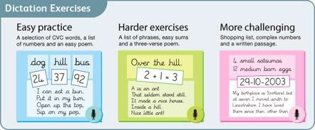
Have full knowledge and ability of the different forms of handwriting for different purposes:
  - Neat, joined, cursive letters for writing passages and large amounts of text, lists and
letters.
  - Printed or capital letters for posters, notices, headings, labelling, and form filling.
  - Speedy handwriting for note-taking and dictation where neatness is not as important
and shortcuts, such as + instead of ‘and’, can
be used.

